Room Booking Website
Introduction:-
Step into the future of seamless digital experiences with our modern Room Booking Application, thoughtfully built using the power and flexibility of React.js. Designed with a perfect blend of innovation and user-centric functionality, this application reimagines how users browse, select, and book rooms—offering a smooth, intuitive, and visually engaging journey from start to finish.
Engineered for today’s fast-paced world, our React-based platform combines robust frontend architecture with an elegant interface that ensures effortless navigation. Whether users are exploring available rooms, managing bookings, or interacting with key UI features, the application delivers a streamlined workflow tailored for clarity and convenience.
Built on Create React App, the heart of this project leverages React’s dynamic component-driven structure to deliver fast load times, responsive layouts, and real-time interactivity. Every element—from reusable components to state management—works together to create a cohesive and immersive experience across desktops, tablets, and mobile devices.
Say goodbye to outdated, complicated booking systems. With this React-powered Room Booking App, users gain access to a smart, efficient, and aesthetically refined platform that transforms the way reservations are made. Welcome to a new era of digital booking—simple, responsive, and delightfully intuitive.
Scenario-Based Intro:-
Imagine you’re planning a short business trip or a peaceful weekend getaway. You sit down with your laptop, coffee in hand, ready to find the perfect room that suits your schedule and comfort. You open our Room Booking Application, designed to make your booking experience effortless and enjoyable.
The application welcomes you with a clean, user-friendly interface crafted using React.js. The responsive layout adjusts smoothly to your device, whether you’re browsing on a desktop, tablet, or smartphone. Attractive visuals, intuitive navigation, and a clutter-free design ensure that your search for the ideal room becomes an enjoyable part of your day.
You begin exploring available rooms. With detailed room descriptions, real-time availability, and clear pricing, the platform helps you make quick and informed decisions. Need to compare different rooms? The easy-to-read layout and interactive components make the process smooth and hassle-free.
Later, you decide to finalize a booking. With the app’s seamless booking workflow, you can select dates, confirm room details, and proceed with your reservation—all in just a few clicks. Built on React’s dynamic capabilities, the system updates instantly, ensuring you receive accurate information without any delays.
Whether you're planning ahead or booking last-minute, the Room Booking Application transforms a traditionally stressful process into a simple, enjoyable, and reliable experience.
Target Audience:-
The Room Booking Application is designed to serve a wide range of users who seek a simple, efficient, and reliable way to reserve rooms for various purposes. This platform caters to:
1. Students
Students looking for study rooms, hostel rooms, or short-term accommodation can easily browse and book available spaces without hassle.
2. Working Professionals
Employees traveling for business meetings, conferences, or temporary office stays can quickly find suitable rooms that match their schedules and preferences.
3. Travelers & Tourists
Individuals planning vacations, weekend trips, or casual getaways can use the platform to explore room options and secure bookings effortlessly.
4. Event Organizers
People arranging workshops, seminars, or small events can book rooms that offer the right capacity and amenities.
5. Property Managers & Administrators
Administrators responsible for managing rooms, hostels, guest houses, or corporate accommodations can streamline booking operations and maintain accurate availability records.
6. General Users
Anyone who needs a quick and convenient solution for reserving rooms—whether for rest, work, or travel—can rely on the app’s easy and user-friendly interface.
General Room Seekers: Individuals who frequently search for comfortable, affordable, and easily accessible rooms—whether for short stays, study sessions, or personal use—who value convenience, clarity, and quick booking options.
Project Goals and Objectives:-
The primary goal of the Room Booking Application is to provide a seamless, efficient, and user-friendly platform for individuals to search, compare, and book rooms effortlessly. Designed with modern web technologies like React.js, the project aims to simplify the entire booking process while delivering a smooth and intuitive user experience.
Key Objectives Include:
1. Simplify the Room Booking Process
To offer users an easy and intuitive interface where they can quickly browse available rooms, check details, and confirm bookings without confusion or delays.
2. Ensure Real-Time Availability
To provide accurate, instant updates on room availability, ensuring users always make well-informed booking decisions.
3. Deliver a Responsive and Consistent User Experience
To create a platform that adapts seamlessly across devices—desktop, tablet, and mobile—offering a uniform and smooth interaction for all users.
4. Improve Decision-Making Through Clear Information
To present room features, pricing, descriptions, and amenities in a clean, organized manner that helps users choose the best option for their needs.
5. Enhance User Trust Through Transparent Booking Flow
To ensure the booking process is clear, secure, and reliable, minimizing errors and building confidence in the platform.
6. Optimize Performance With Modern Frontend Technologies
To utilize React’s component-based architecture for faster rendering, efficient state management, and a better overall performance experience.
7. Support Future Scalability
To develop the application in a way that new features—like user login, payment integration, or admin controls—can be added without major redevelopment.

Key Features:-
⮚ Room Listings & Descriptions:
A dedicated section showcasing all available rooms with detailed descriptions, including amenities, pricing, room type, and capacity.
⮚ Real-Time Availability:
Instant updates on room availability, ensuring users can book rooms confidently without encountering outdated or incorrect information.
⮚ Interactive Booking System:
A smooth and intuitive booking interface that allows users to select dates, review room details, and confirm reservations effortlessly.
⮚ Responsive User Interface:
A fully responsive design built with React.js, allowing users to browse and book rooms seamlessly on desktops, tablets, and mobile devices.
⮚ Search & Filter Options:
Advanced filters enabling users to refine their search based on price, room type, amenities, and availability.
⮚ User-Friendly Navigation:
Clean, organized layouts and interactive components that make browsing and booking fast, simple, and enjoyable.
⮚ Scalable Frontend Architecture:
React’s component-based structure ensures smooth performance and allows the application to expand with additional features in the future.
⮚ Modern UI/UX Design:
A visually appealing interface with clear visuals, intuitive interactions, and a pleasant user experience throughout the booking process.

PRE - REQUISITES:-
Developing the Room Booking Application using React.js requires certain tools, technologies, and basic foundational knowledge. Below are the essential prerequisites every developer should have before starting the project:

⮚ Node.js and npm
Node.js is a JavaScript runtime environment that allows you to execute JavaScript outside the browser. It is required for installing packages, running development servers, and managing React applications. npm (Node Package Manager) comes bundled with Node.js and is used to install and manage the dependencies of the project.
Before beginning development, ensure that Node.js and npm are installed on your system.
- Download Node.js: https://nodejs.org/en/download/
- Installation instructions: https://nodejs.org/en/download/package-manager/

⮚ React.js
React.js is the core technology used to build the Room Booking Application. It is a popular JavaScript library for creating fast, interactive, and reusable user interface components. React enables efficient rendering and smooth user experiences, making it ideal for responsive applications like this room booking system.
To begin development, you must be familiar with how to create a new React project, navigate through the project structure, install necessary dependencies, and run the development environment.

⮚ HTML, CSS, and JavaScript
Basic understanding of web development languages is essential:
- HTML for structuring the web pages and components
- CSS for styling and designing the user interface
- JavaScript for adding interactivity, logic, and dynamic functionality
These skills help in customizing components, creating layouts, and implementing application features effectively.

⮚ Version Control (Git)
Git is an essential tool for tracking code changes, collaborating with team members, and maintaining versions of your project safely. Platforms like GitHub, GitLab, and Bitbucket allow developers to store repositories online, manage issues, and work collaboratively.
- Download Git: https://git-scm.com/downloads

⮚ Development Environment (Code Editors)
A comfortable and efficient coding environment helps streamline development. A good code editor provides features like syntax highlighting, debugging, extensions, and intelligent suggestions.
Commonly used editors include:
- Visual Studio Code: A lightweight and powerful editor widely used for React development
- Sublime Text: Fast and simple editor suitable for quick development tasks
- WebStorm: A professional IDE with advanced React and JavaScript support
Download links:
- Visual Studio Code: https://code.visualstudio.com/download
- Sublime Text: https://www.sublimetext.com/download
- WebStorm: https://www.jetbrains.com/webstorm/download

Project structure:
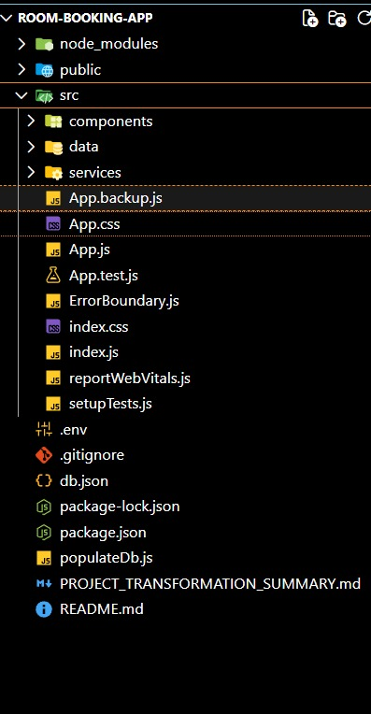
The structure of the project depends on the framework and development practices being followed. In this Room Booking Application built using React.js, the files and folders are organized in a clean and consistent manner to ensure better readability, maintainability, and smooth collaboration among developers.
React applications typically follow a component-based architecture, where each UI section or feature is developed as an independent component. This modular structure helps in efficient reuse of code and simplifies project management.

PROJECT FLOW:-
Project demo:
Before starting to work on this project, let’s see the demo.
Demo link: https://drive.google.com/file/d/1Lm7FOm6irmy9nP4bpGIJ6M3S9CFpnNTj/view?usp=drivesdk%20
Use the code in:
https://d.docs.live.net/b7e9071bc0a44b5d/Desktop/abhinash%20(srmap.edu.in)%20-%20Chrome.lnk
Milestone 1: Project Setup and Configuration:
1. Install Required Tools and Software
To begin building the Room Booking Application, the first step is setting up the development environment and installing all necessary tools.
● Installation of Required Tools
Open the project folder and install the essential tools and libraries required for building the application.
For this project, we use:
- React.js – for building the user interface
- React Router – for navigation between pages
- Material-UI (MUI) – for responsive UI components and styling
- Axios or Fetch API – for handling data requests
- React Icons – for adding icons to improve visual appeal
These tools collectively support the structure, styling, navigation, and dynamic functionality of the room booking system.

● Reference Resources
To understand installation steps or explore further documentation, refer to:
- React Installation Guide:
https://react.dev/learn/installation
- Material-UI Documentation (for styling and components):
https://mui.com/material-ui/getting-started/overview/
- React Router Guide:
https://reactrouter.com/en/main
Milestone 2: Web Development:
1. Setup React Application
During this milestone, the initial development work for the Room Booking Application is carried out.
● Create React Application
Set up the base React project structure and initialize all required configuration files.
● Configure Routing
Implement React Router to enable smooth navigation between key pages such as:
- Home
- Room Listings
- Room Details
- Booking Page
- Confirmation Page
● Install Required Libraries
Add essential libraries that support UI design, API handling, layout structure, and iconography.
● Develop the App.js Component
The App.js file serves as the primary entry point for the application’s layout and routing.
This component:
- Loads the navigation bar
- Handles routing logic
- Renders major screens and components
- Serves as the root wrapper for all other features
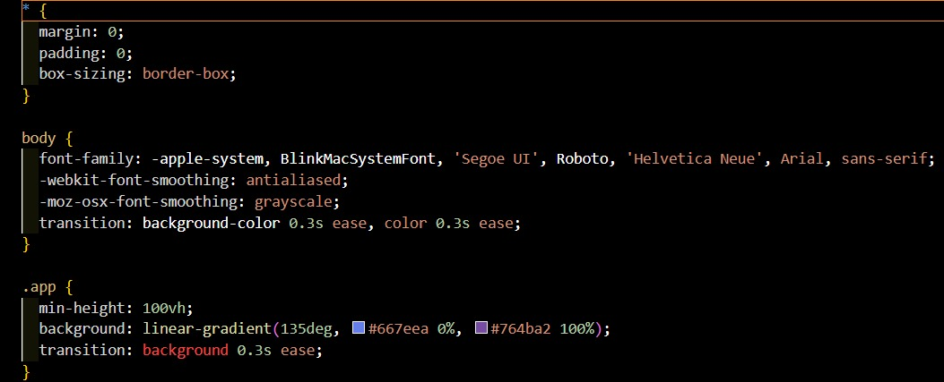
Code Description:-
● ./App.css:

This file contains the global styling for the main App component. It defines layout, spacing, colors, and other visual properties that help maintain a consistent design throughout the application.

● Home from ./components/Home:
The Home component serves as the landing page of the Room Booking Application. It typically displays an introduction, featured rooms, or navigation links to other sections like room listings or booking pages.
● DataProvider from ./context/DataProvider:
This is a context provider responsible for managing and supplying global application state.
It handles data such as room information, user selections, booking details, and shared logic across multiple components.
● App Component Logic:
The main App function returns JSX that renders the DataProvider and the Home component inside it.
This ensures that all components inside the app have access to shared state and context values using React’s Context API.
● Wrapping Components with <DataProvider>:
By wrapping the entire application (starting with the Home page) inside the DataProvider, the Room Booking Application ensures that components can:
- Access global state
- Share booking data
- Manage availability
- Update UI based on user interactions
● <Home /> Component:
This is the primary page loaded inside the app. It acts as the entry point for users and may contain banners, search bars, navigation options, and links to other booking-related pages.
● Exporting App Component:
The App component is exported as the default module so that it can be imported into index.js, where it is rendered into the DOM as the root of the entire React application.

2. Design UI Components
● Create Components
Build individual reusable components such as:
- Room Cards
- Navigation Bar
- Search Filters
- Footer
- Booking Form
- Room Details Section
These components shape the user interface and allow modular development.
● Implement Layout and Styling
Use CSS, Material-UI, or styled components to design:
- Page layouts
- Typography
- Buttons and forms
- Grid systems
- Responsive designs
This ensures the Room Booking Application remains clean, attractive, and user-friendly.
● Add Navigation
Implement React Router for smooth navigation between pages like:
- Home
- Room List
- Room Details
- Booking Page
- Confirmation Page

3. Implement Frontend Logic
● Integration with API Endpoints
Connect the frontend with backend services (if available) to:
- Fetch room data
- Retrieve availability
- Submit booking information
- Update user selections
Data fetched from APIs is displayed dynamically across components.
● Implement Data Binding
Ensure that user interactions update the UI in real time.
Examples include:
- Updating selected dates
- Dynamically showing available rooms
- Displaying booking confirmation details
- Changing filters and instantly updating results

Data Provider:-
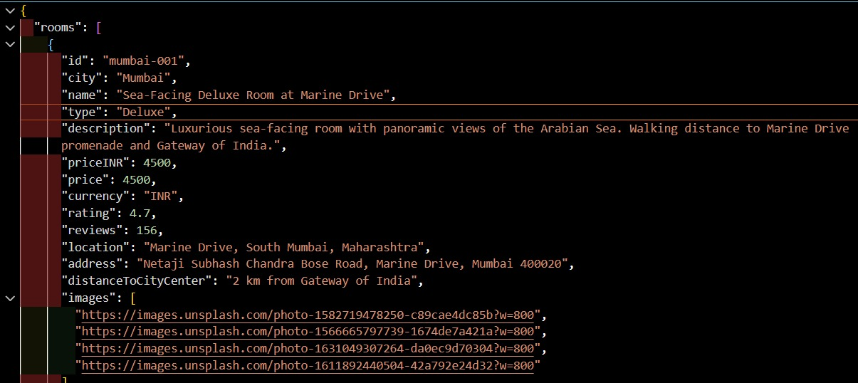
Code Description:-
● Creates a DataContext using createContext(null) to store shared booking-related data
A DataContext is created to hold global information such as available rooms, selected room details, booking information, and user inputs used throughout the Room Booking Application.

● Defines a DataProvider component that wraps around other components to supply shared data
The DataProvider acts as the central provider that distributes room-related data and application state to all child components, ensuring consistent access across pages.

● Uses useState hooks to create state variables for rooms, selectedRoom, and bookingDetails, along with their respective setter functions
The provider manages multiple state variables, such as:
- rooms – stores the list of rooms fetched or defined
- selectedRoom – holds the details of the room chosen by the user
- bookingDetails – stores selected dates, number of guests, and booking info
Each state variable is initialized with default values such as empty arrays or empty objects.

● Returns a DataContext.Provider with a value property containing all the state variables and their setters
These values are then accessible to any nested component, allowing them to read and update shared data without prop drilling.
This improves maintainability and ensures real-time updates to room availability and booking.

● Exports the DataProvider component so it can be used across the application
The DataProvider is exported as the default export, allowing it to wrap the main App component or specific sections that need shared state.

● Wrap the DataProvider around components that require access to room or booking data
Components such as Home, RoomList, RoomDetails, and BookingPage must be wrapped inside the provider so they can retrieve and modify global context values.

● Access and manipulate shared booking data in nested components using the useContext hook
Child components can use useContext(DataContext) to:
- Display room information
- Update selected room
- Modify booking details
- Apply filters or search queries
This ensures efficient data sharing and seamless user interaction throughout the Room Booking Application.
Code Component:- 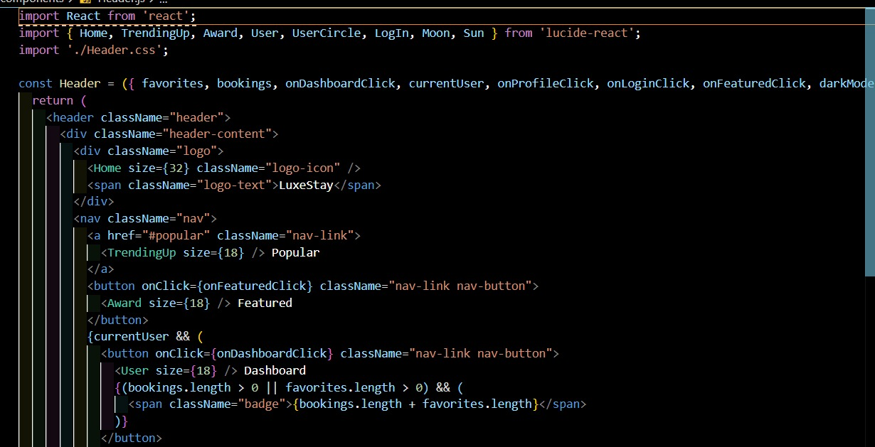
Code Description:-
● Imports useContext from React to access shared application data
The component imports the useContext hook to retrieve booking-related data such as available rooms, selected room details, and user selections from the global context.

● Imports UI components and styling tools (e.g., Material-UI components like Box and styled)
These components are used to design layouts, create responsive containers, and apply consistent styling throughout the Room Booking Application.

● Imports DataContext from the custom DataProvider to access shared state values
This allows the component to access global data such as the list of rooms, selected room information, and booking details.

● Creates a styled component Container using Material-UI’s styled and Box
The Container is a layout wrapper used to arrange room cards, booking details, or other UI elements in a structured and visually appealing manner.

● Styles the Container with properties such as background color, height, padding, and flex display
These styling rules ensure the section is responsive, properly aligned, and visually consistent with the overall design of the application.

● Defines the RoomList (or similar) component which uses useContext to access rooms, selectedRoom, and booking-related data
The component retrieves values from the context such as:
- rooms – list of available rooms
- setSelectedRoom – function to update selected room
- bookingDetails – user’s chosen dates or preferences

● Renders multiple RoomCard components inside the Container
Each RoomCard component represents a single room and typically displays:
- Room name
- Price
- Availability
- Room image
- Short description

● Each RoomCard is configured with:
- room prop – passes the room’s data
- onSelect prop – allows user to select the room
- image prop – displays a room photo
- price prop – shows the room’s cost
- amenities or features props – shows facilities available in the room
- custom colors or icons – for improving aesthetic appeal and usability

● Exports the component as the default export so it can be used across the application
This makes the RoomList (or similar component) available for integration inside pages such as:
- Home
- Room Listings
Project Execution:
After completing the code, run the react application by using the command “npm start” or “npm run dev” if you are using vite.js
Here are some of the screenshots of the application.
- Home component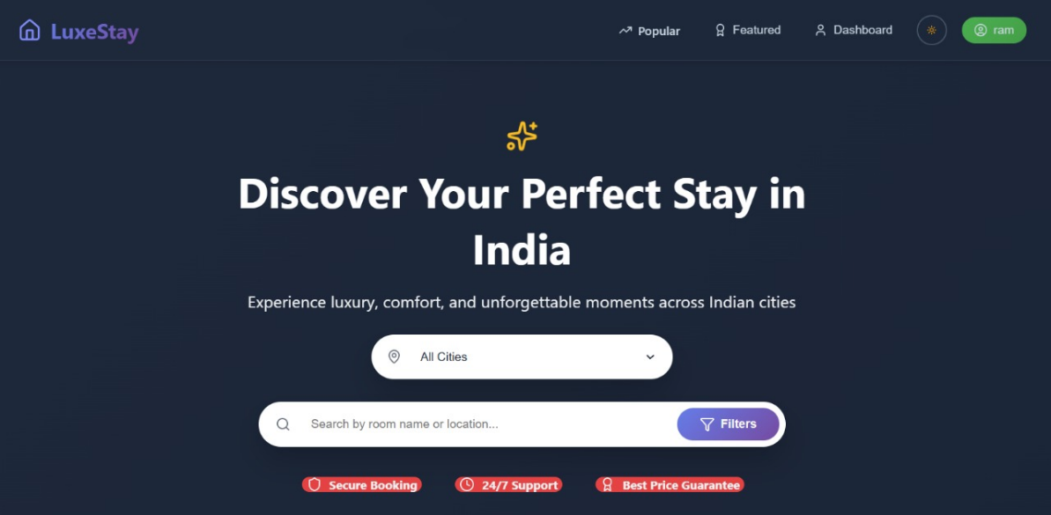

- CSS Code Component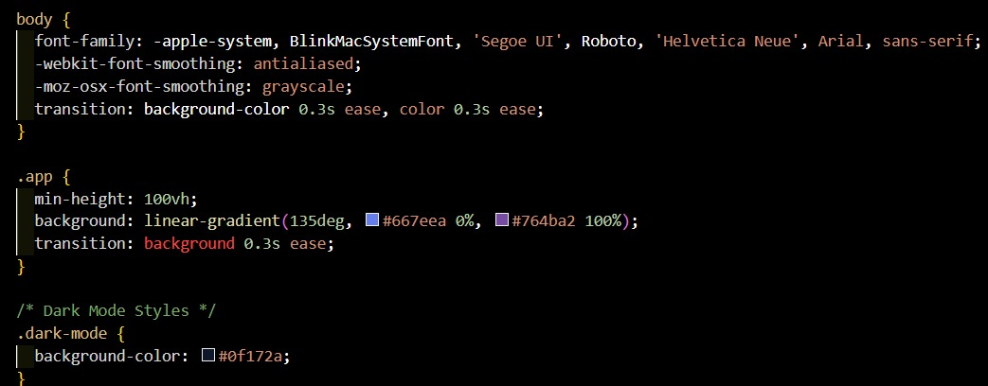
- Javascript Component
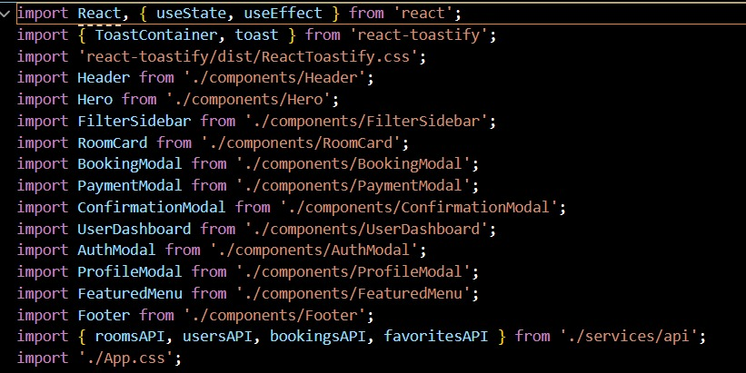

- Final Home Component
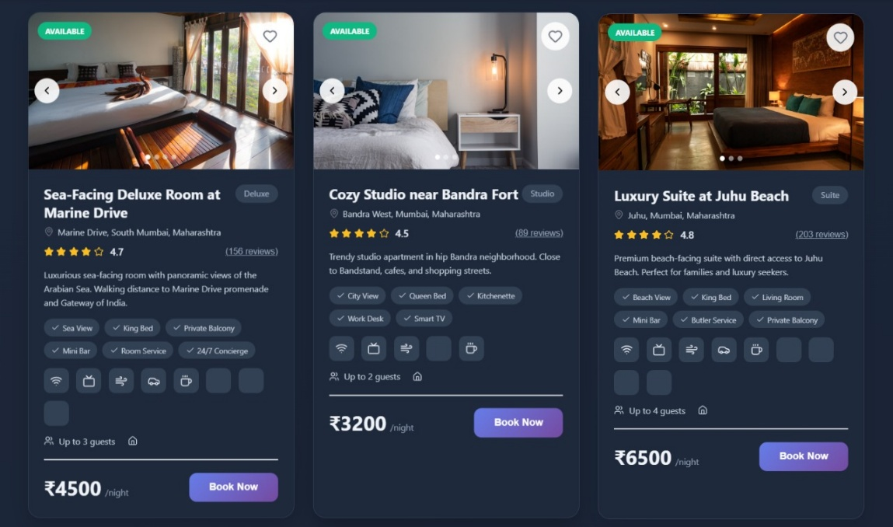

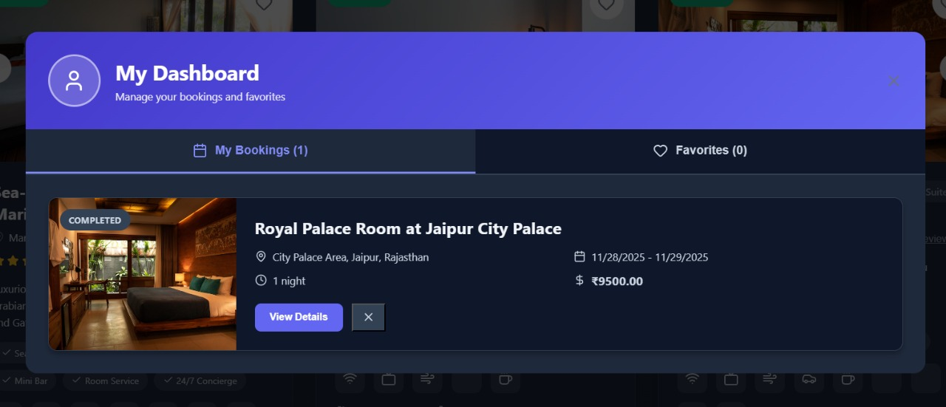
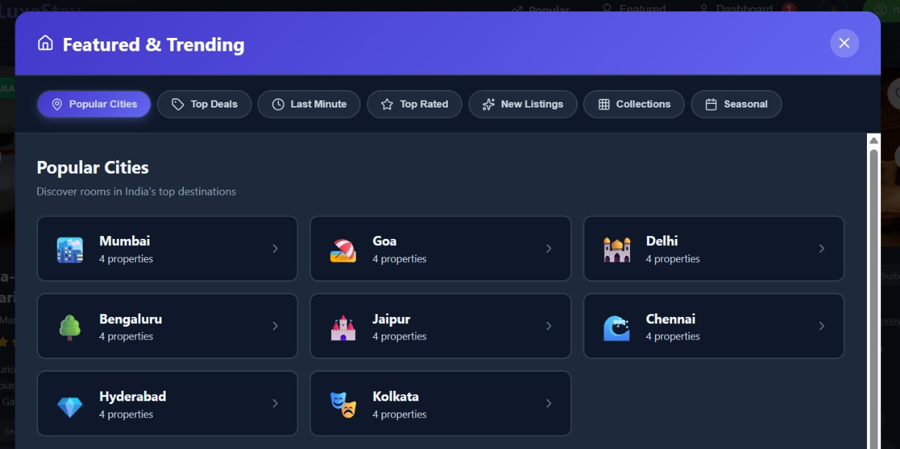
Project Demo link:
https://drive.google.com/file/d/1Lm7FOm6irmy9nP4bpGIJ6M3S9CFpnNTj/view?usp=drivesdk
Github Repository: https://github.com/nikhilkumar905/LUXESTAY

